CSCI 213

**FINAL PROJECT**

Part 3A

**Team members:** Zachary King, Carter Dewolfe, Andrew Hershberger

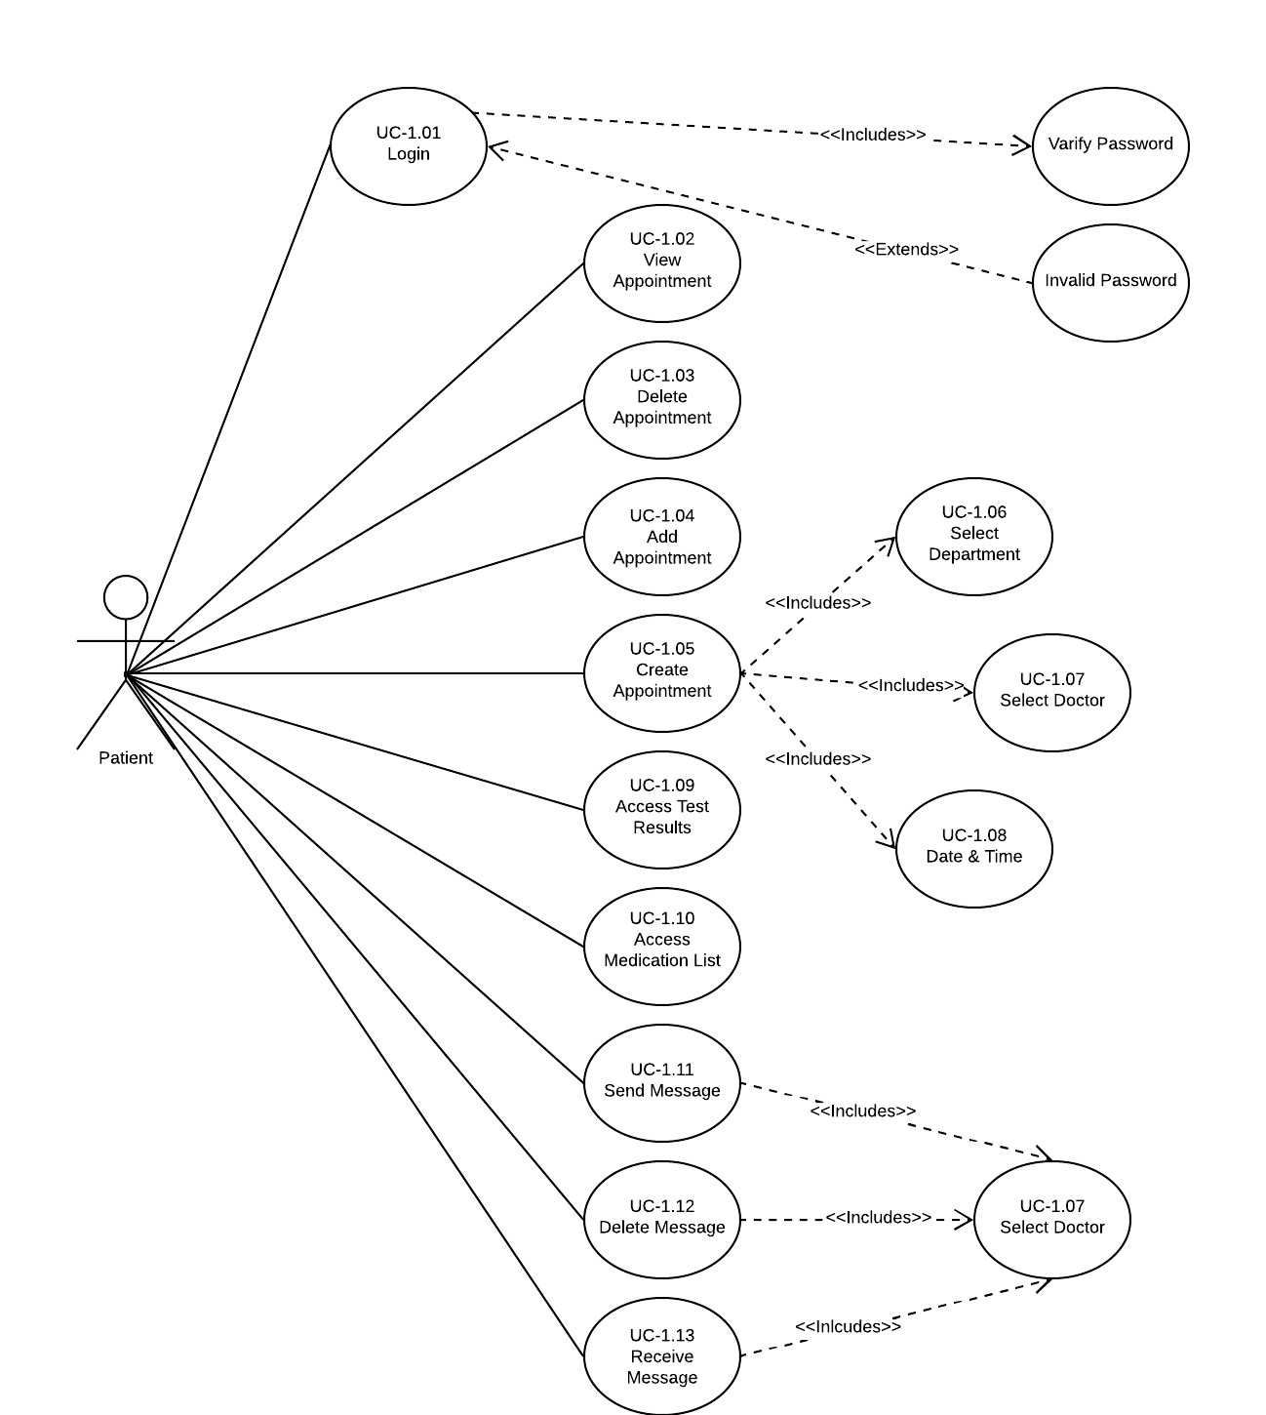

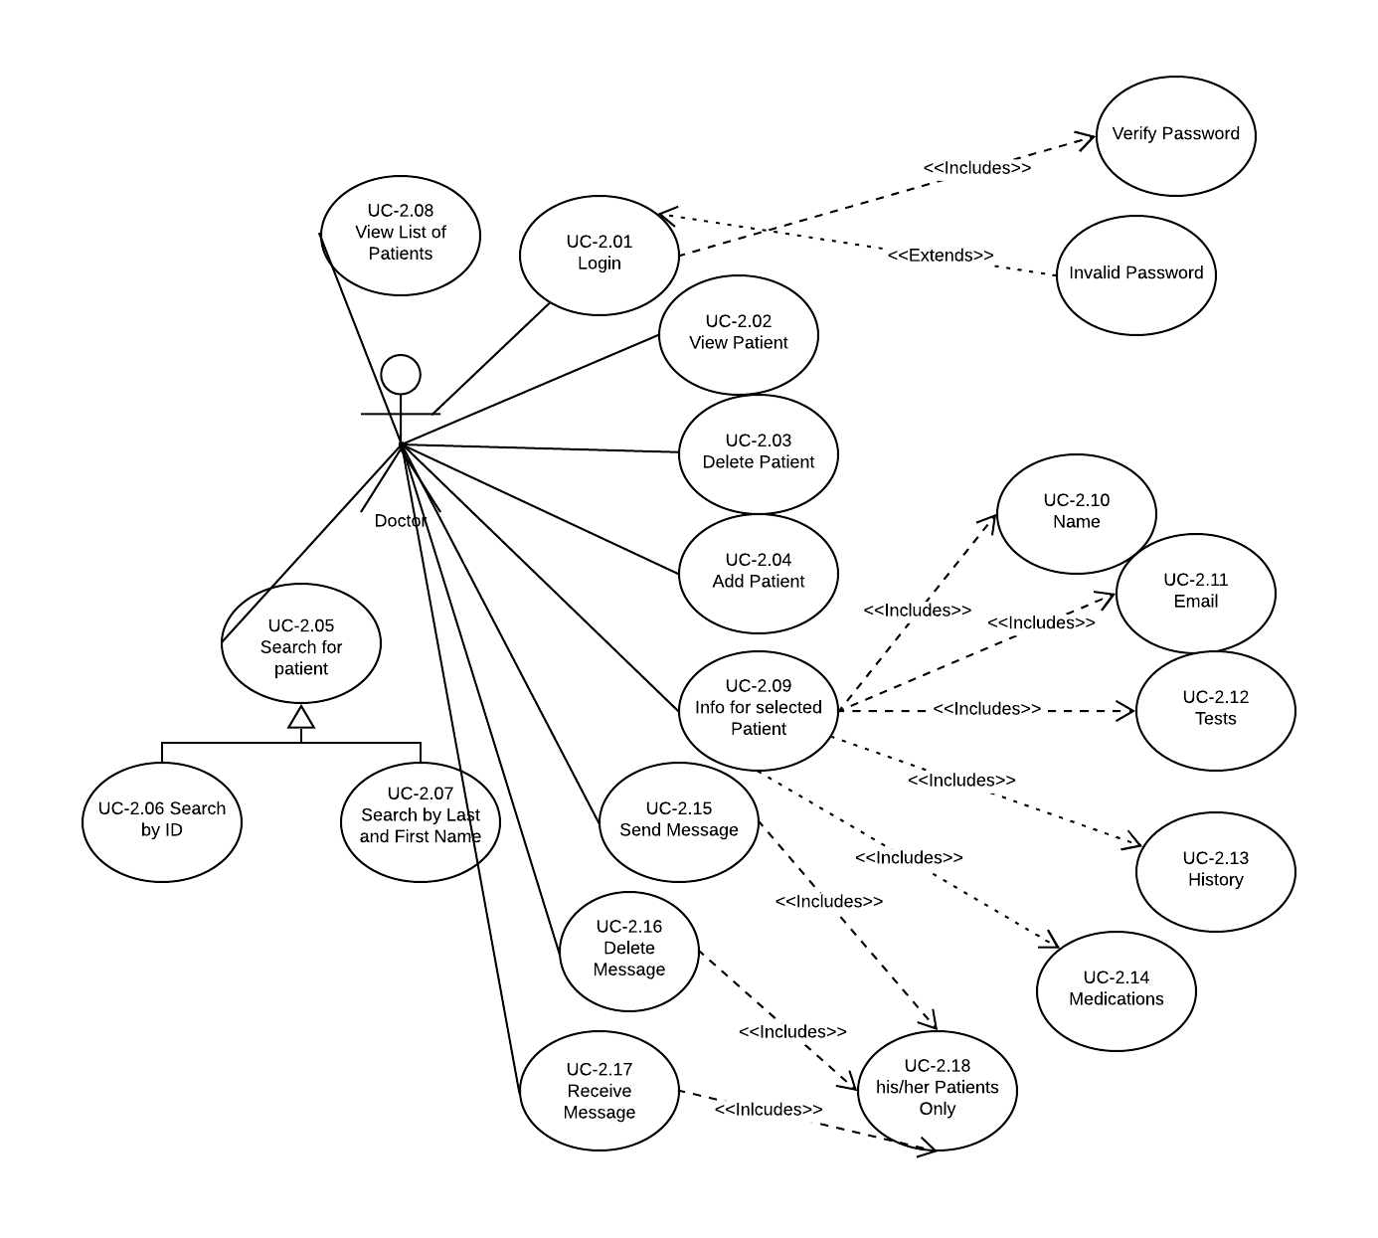

1. Identify Functional Requirements

|  |  |  |
| --- | --- | --- |
| **Requirement N** | **Description** | **Use-case Number** |
| REQ1 | Login | UC-1.01 |
| REQ2 | View Appointment | UC-1.02 |
| REQ3 | Delete Appointment | UC-1.03 |
| REQ4 | Add Appointment | UC-1.04 |
| REQ5 | Create Appointment | UC-1.05 |
| REQ6 | Select Department | UC-1.06 |
| REQ7 | Select Doctor | UC-1.07 |
| REQ8 | Select Date & Time | UC-1.08 |
| REQ9 | Access Test Results | UC-1.09 |
| REQ10 | Access Medication List | UC-1.10 |
| REQ11 | Send Message | UC-1.11 |
| REQ12 | Delete Message | UC-1.12 |
| REQ13 | Receive Message | UC-1.13 |

|  |  |  |
| --- | --- | --- |
| **Requirement N** | **Description** | **Use-case Number** |
| REQ1 | Login | UC-2.01 |
| REQ2 | View Patient | UC-2.02 |
| REQ3 | Delete Patient | UC-2.03 |
| REQ4 | Add Patient | UC-2.04 |
| REQ5 | Search Patient | UC-2.05 |
| REQ6 | Search by Patient ID | UC-2.06 |
| REQ7 | Search by lastN and firstN | UC-2.07 |
| REQ8 | View Patient List | UC-2.08 |
| REQ9-14 | Return Patient Info (Name, Email, Tests, History, Medications) | UC-2.09 – 2.14 |
| REQ15 | Send Message | UC-2.15 |
| REQ16 | Delete Message | UC-2.16 |
| REQ17 | Recieve Message | UC-2.17 |
| REQ18 | Only send messages to people in contact list | UC-2.18 |

1. Use-case diagram for Patient.
2. Use-case diagram for Doctor.
3. Use-case Description for “Make an Appointment with Doctor”

# Use Case # [1.05: Create Appointment]

|  |  |
| --- | --- |
| **GENERAL CHARACTERISTICS** | |
| **Intent** | Create an appointment with a user specified department, doctor and a date and time |
| **Primary Actor** | Patient |
| **Secondary Actors** | Doctor  Department  Date and Time |
| **Preconditions** | Doctor table is populated  Department table is populated  Patient is logged in |
| Assumptions | Doctor has open slot in their time schedule |
| **Success Post Condition** | Appointment was created with specified doctor time and department |
| **Failed Post Condition** | Appointment failed to create this could be due to doctor not existing in database or department |

|  |  |
| --- | --- |
| **MAIN SUCCESS SCENARIO** | |
| **Step** | **Action** |
| S | The Patient successfully schedules an appointment and required fields are updated |
| 1 | Patient specifies department |
| 2 | Patient specifies doctor |
| 3 | Patient specifies time |
| 4 | Doctor’s time schedule is updated |
| 5 | This use case ends when the appointment is created the doctor’s time schedule is updated and the department is retrieved from doctor DB entry |

|  |  |
| --- | --- |
| **ALTERNATIVE SCENARIOS** | |
| **Step** | **Branching Action** |
| *n..m* | [description in words of the extension scenario] <[pointer to scenario diagrams for the extension scenario]> |
| [An extension scenario indicates the step or range of steps in the main success scenario where possible branching occurs, and the resulting actions which vary from the main success scenario. Identify the step number of main scenarios where branching action occurs (*n*), and list the condition followed by the actions.]  [na. Condition causing branching:]  [*n*a1. Action (or name and number of “extend” use case)]  [*n*a2. Action (or name and number of “extend” use case)] |
|  |  |

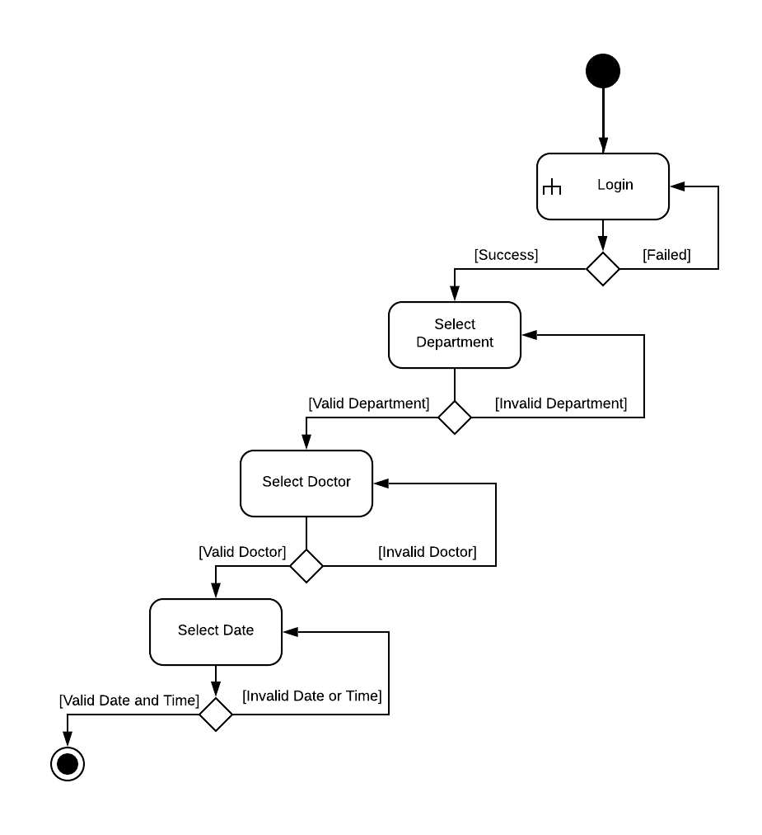

1. Activiti diagram for “Make an Appointment with Doctor”

|  |  |
| --- | --- |
| 1. **As a** | **I should be able** |
| Patient | Login |
| Patient | View, delete, and add appointments |
| Patient | Create a new appointment |
| Patient | Access his/her test results or medication list |
| Patient | Send, delete, and receive message to/from selected doctor |
| Doctor | Login |
| Doctor | View, delete, and add his/her patient’s appointments |
| Doctor | Search for her patients by patient ID or last and first name |
| Doctor | View the list of patients and all the information for selected patients |
| Doctor | Send, delete, and receive message to/from selected doctor |